Always wonderful to see so many children scooting along the pavement to school. It’s a fantastic way to start the day and stay active!
So that everyone is safe please can children step off when they enter through the gate. Thank you!
Scooters
Open days for Reception 2024

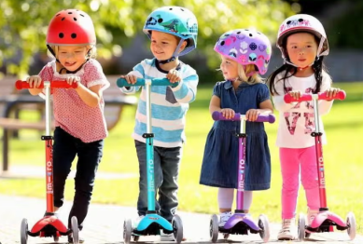
We are really looking forward to getting started with our sustainability programme after the half term break. Our first theme is waste and consumption.
We’ll be holding another coat swap, toy repair centre, and drop and swap events soon. We have also been reviewing our recycling in school and are going to be enlisting the help of The Green Centre at the Open Market with how we can reycle more ofour plastic waste.

Our City, Our World

Do you have a child starting school in September 2024, or know someone who does? Come and join us for a tour.
Monday 6th November 9.30am
Tuesday 7th November 9.30am
Wednesday 8th November 6.00pm
Thursday 9th November 1.30pm
Tuesday 14th November 9.30am
Thursday 16th November 6.00pm

On Saturday 4th November (10am -2pm) we’ll be having our first Chip in day of the year. Come lend a hand in the next stage of developing our much loved outdoor learning spaces for learning and wildlife alike. Children welcome! No experience needed, just a willingness to get stuck in. We’ll end the day with well-earned soup and bread around the campfire.

Chip in Day
Workshops
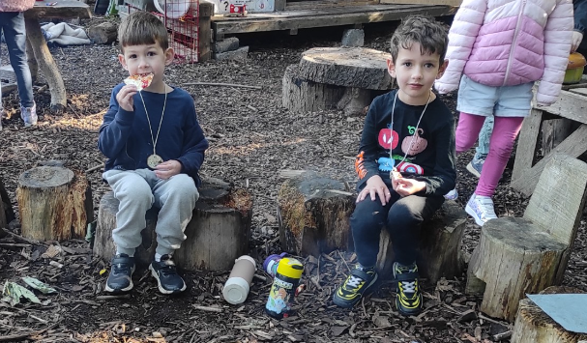
It was wonderful to see so many people attend the reading meetings held over the last couple of weeks. Mrs Meegan was able to guide Reception and Key Stage 1 parents through how we teach phonics.
For those of you who weren’t able to make it please do take a look at the Little Wandle website and look out for the weekly phonics pings.
https://www.littlewandlelettersandsounds.org.uk/resources/for-parents/
Key dates
Outdoor Learning Day | Thursday 2nd November
Quiz Night! | Thursday 2nd November 7pm
Flu Vaccinations | Friday 10th November
Nursery Stay & Play | Tuesday 14th & Thursday 16th November  2.30-3.00
KS1 Parents maths meeting (Year 1 & Year 2) | Wednesday 15th November  5.30-6.30
Christmas Lunch | Wednesday 6th December
Christmas Disco | Friday 8th December
Year 2 Church – Grandparents invited | Tuesday 12th December time TBC
Christmas Performances
Reception show | Tuesday 5th December  9.30am
Year 1 show | Thursday 7th December  9.30am
Year 2 show | Thursday 7th December  2pm
Nursery | Wednesday 13th December  2pm
Last day of term Friday 15th December
New events in bold
Just wanted to say a huge thank you to everyone who contributed to getting our Forest School canopy repaired and upgraded! We were blown away by the generous donation from The Ladies Mile as well as the support given for free by Union Tree and Garden Service. The canopy is better than it has ever been before and just in time for the glorious weather.
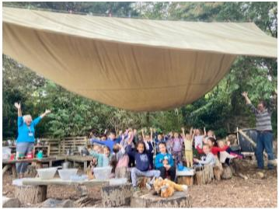
Forest School
Helen Hawkins
Headteacher
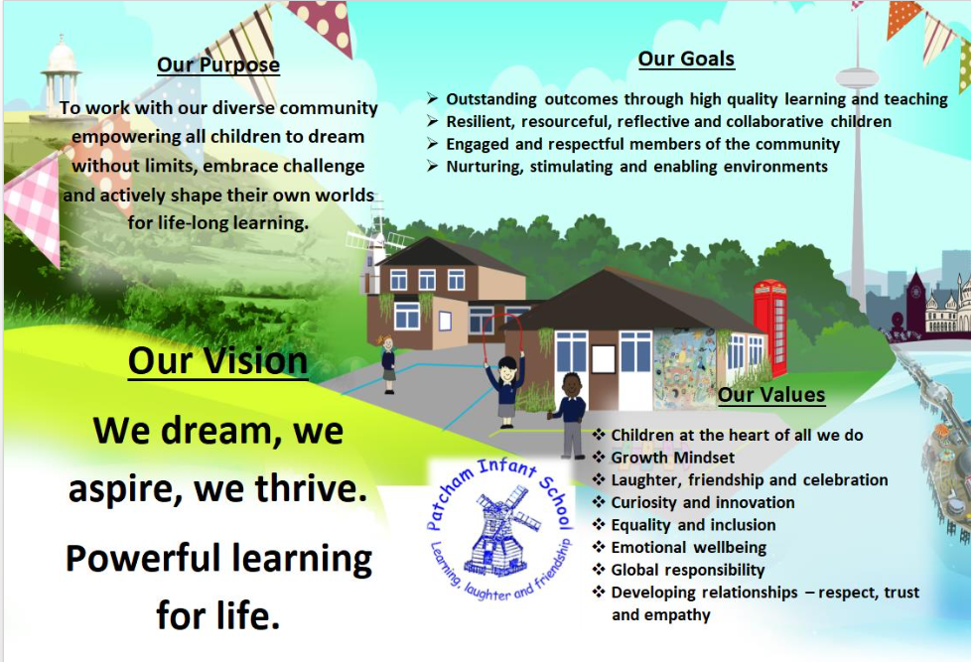
20th October 2023
Autumn term – Newsletter 2
Have a fabulous half term break. See you all again on Tuesday 31st October.

What a half term!

Year 1 have been exploring addition with the part whole model and creating their own. 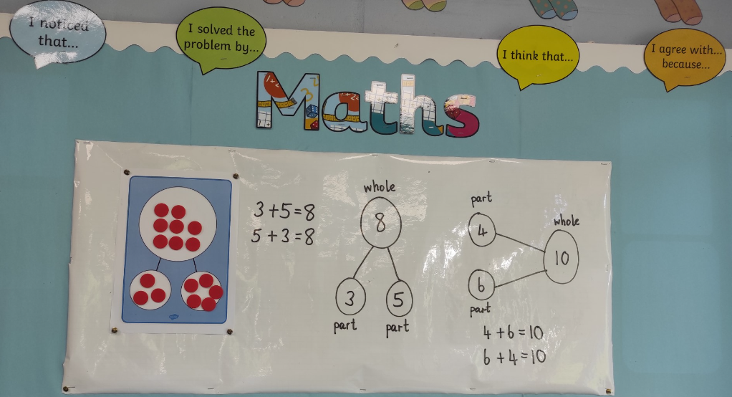

Incy Independent has landed in Nursery and Reception and we have all been blown away with how much the children have learnt about being independent learners and spiders!
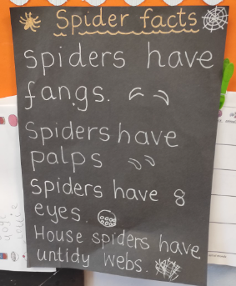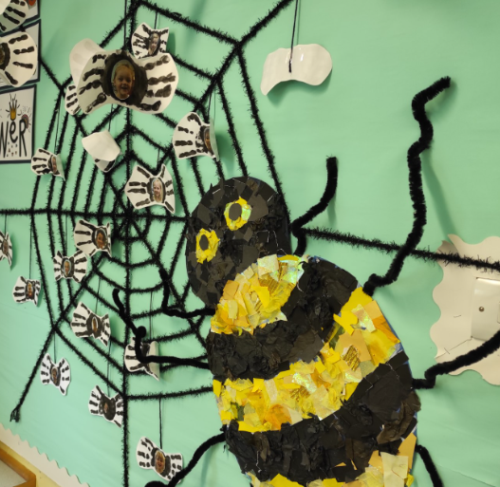
Year 2 have been fantastic historians, learning about the Great Fire of London and produced some wonderful collages.
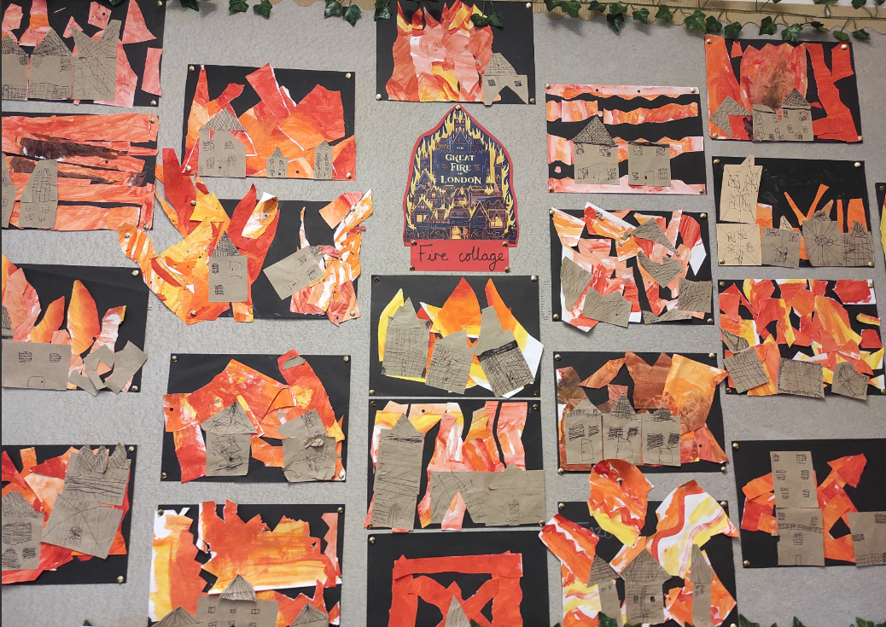
There has been some fantastic learning taking place all over the school, here’s a little taste…
The Harvest collection was truly amazing. Thank you so much for your generosity. The Gathering Place was overwhelmed with our donation and it really will make a huge difference to many families.
Amazing news
