Super Starts all over the school…

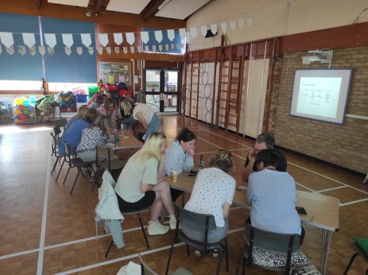
Meetings will be held on Tuesday 17th and Thursday 19th October
You will be able to sign up on School Ping from Wednesday 4th October

Parent & carer consultations

I am delighted to announce that we will be taking part in the city-wide climate change, sustainability and environmental education programme, Our City, Our World.
Staff have already taken part in two training days and we are all really looking forward to launching it with the whole community after half-term. Watch out on your ping for a pre-project survey for you and your child.

I’d like to welcome some new members of staff to the team.
Katie Shine is teaching in Ladybird Class
Gemma Oswald is teaching in Dragonfly Class
We have also welcomed Sarah Harrup to the office team on Thursdays and Fridays.
I know that you will make them all feel very welcome.

Our City, Our World

Welcome
Each year group’s Learning Journeys have got off to a great start. Big Questions and topics this term are:
Nursery – These are a few of my favourite things.
Reception – You’ve got a friend in me.
Year 1 – What’s in your toy box?
Year 2 – What lights up your life?
Do look out on the school website for photos of these super starts.

Key dates
Year 2 - Welcome grownups to new classrooms – children to show grown-ups their new classroom – treasure hunt. | Wednesday 20th September  3pm
Year 1 - Welcome grownups to new classrooms – children to show grown-ups their new classroom – treasure hunt. | Thursday 21st September  3pm
Reception Parents reading meeting | Wednesday 4th October  5.30-6.30pm
KS1 (Year 1 & 2) Parents reading meeting | Thursday 12th October  5.30-6.30pm
Reception Stay & Play | Thursday 5th October  2.45-3.15pm
Harvest collection | Friday 13th October
Individual Photos | Wednesday 18th October
PTA Cake sale | Friday 20th October
Outdoor Learning Day | Thursday 2nd November
Flu Vaccinations | Friday 10th November
Nursery Stay & Play | Tuesday 14th & Thursday 16th November  2.30-3.00
KS1 Parents maths meeting (Year 1 & Year 2) | Wednesday 15th November  5.30-6.30
Christmas Disco | Friday 8th December
Christmas Performances
Reception show | Tuesday 5th December  9.30am
Year 1 show | Thursday 7th December  9.30am
Year 2 show | Thursday 7th December  2pm
Nursery | Wednesday 13th December  2pm
Helen Hawkins
Headteacher
Monday 30th October
Tuesday 2nd January
Friday 9th February
Friday 24th May
Do you have a spare hour to come and read in school? We are looking for volunteers to read with children and Fred our amazing reading dog. Please look out for the school Ping for more information.
Reading Dog

Inset days
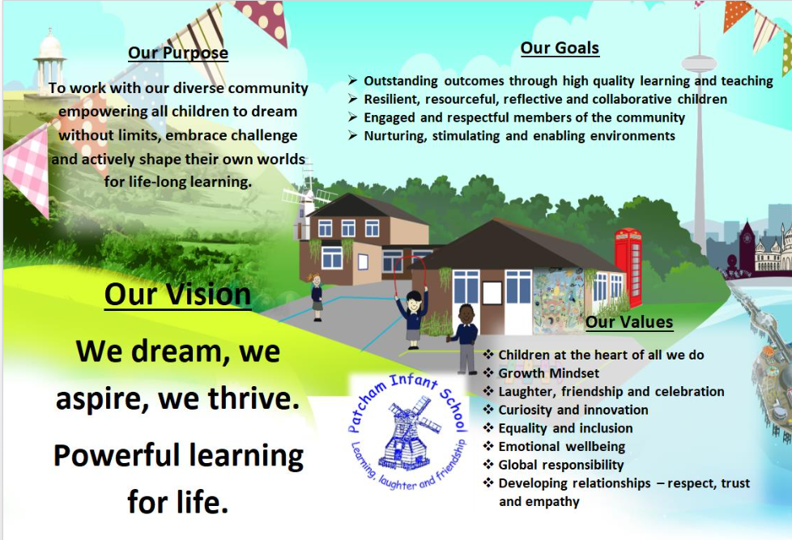
Welcome back to the new school year and the autumn term! We have had a fabulous first couple of weeks with our new Year One and Year Two classes who have got straight into their learning with an enthusiasm that has been wonderful to see.
Reception and Nursery children have made a fantastic start to school and we’re all looking forward to another year of learning, laughter and friendship!

21st September 2023
Autumn term – Newsletter 1

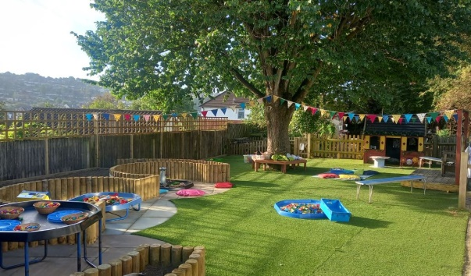
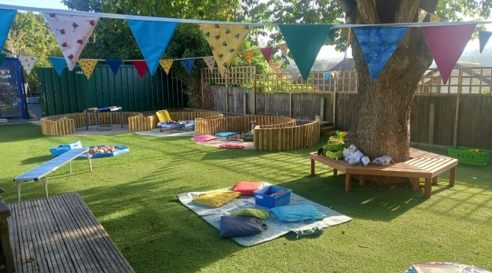
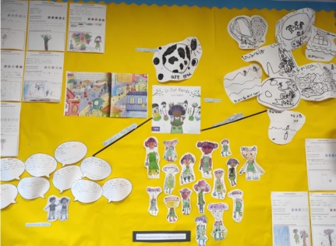
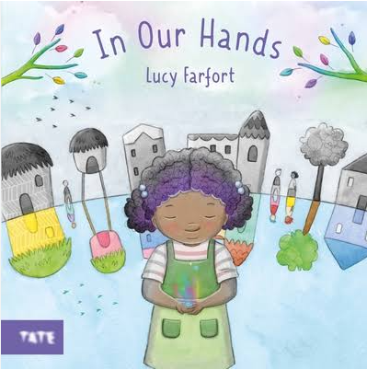
Over the summer holidays we have been busy making some much needed improvements to the Reception outside classroom. The space is now absolutely stimulating and nurturing and the Reception children are already showing themselves to be amazing caretakers in looking after the area.
Huge, huge thanks must go to the PTA for supporting with this endeavour and the amazing efforts of Good Construction who worked tirelessly over the summer to make the vision a reality.

Amazing news
This year for the first two weeks back to school Year 1 and Year 2 enjoyed the beautiful book In Our Hands.
A story about working together and building a community. In the story a group of determined children grow a seed of hope that inspires everyone to come together and build a better future.

Welcome back

